EXERCISE 4.2

**NCERT Solutions for Class 10 Chapter 4-**

**Quadratic Equations**

EXAMBUDDY

Question 1:

Find the roots of the following quadratic equations by factorisation:

1. x2 -3x – 10 = 0  
   (ii) 2x2 + x – 6 = 0  
   (iii) √2x2 + 7x + 5√2 = 0  
   (iv) 2x2 – x + 18 = 0 8  
   (v) 100 x2 – 20 X + 1 = 0

**Solution:**

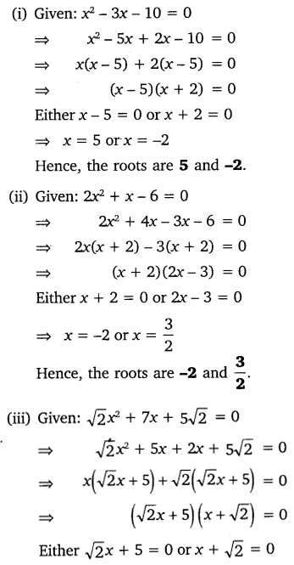

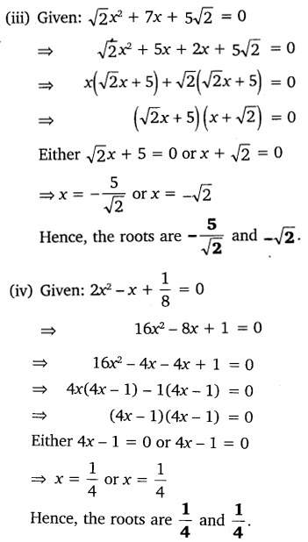



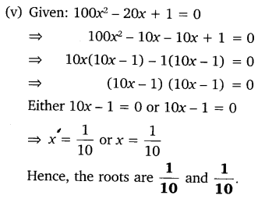

Question 2:

Solve the following situations mathematically:

1. John and Jivanti together have 45 marbles. Both of them lost 5 marbles each and the product of the number of marbles they now have is 124. We would like to find out how many marbles they had to start with.
2. A cottage industry produces a certain number of toys in a day. The cost of production of each toy (in rupees) was found to be 55 minus the number of toys produced in a day. On a particular day, the total cost of production was ₹750. We would like to find out the number of toys produced on that day.

Solution:

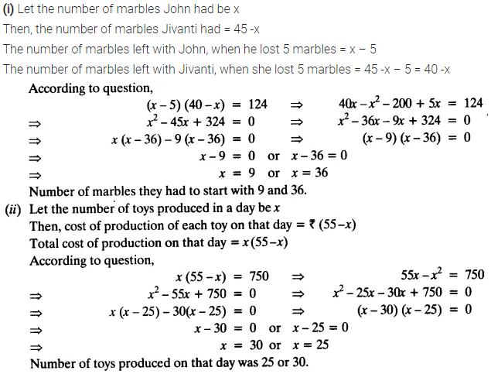

Question 3:

Find two numbers whose sum is 27 and product is 182.

Solution:

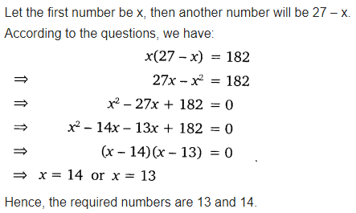

Question 4:

Find two consecutive positive integers, the sum of whose squares is 365.

Solution:

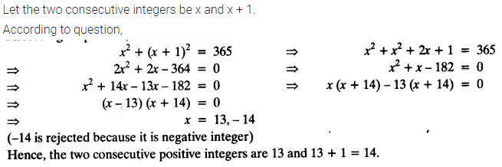

Question 5:

The altitude of a right triangle is 7 cm less than its base. If the hypotenuse is 13 cm, find the other two sides.

Solution:

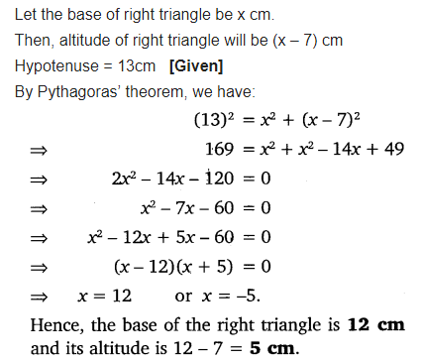

Question 6:

A cottage industry produces a certain number of pottery articles in a day. It was observed on a particular day that the cost of production of each article (in rupees) was 3 more than twice the number of articles produced on that day. If the total cost of production on that day was ₹90, find the number of articles produced and the cost of each article.

Solution:

